**Spring Boot with Docker Container | DockerFile | Example | Simple Programming**

Welcome to Simple Programming

In this video, let us see how to Containarize your spring boot application using Docker

I will do a tutorial series on Docker and we shall look at things like Docker Compose, Swarms etc

but for this example, let me quickly give you an idea about containerization and will help you to quickstart your containarization journey with docker

Now what is meant by Containarization with Docker

Let me give you a simple use case for better understanding.

lets say you have a web server, database, messaging service, etc… and you have to ship your application to multiple centers and make it run in those platforms.

for this you have to make sure that all these services are supported by the underlying OS. Application built on one OS can’t be guaranteed to run in another OS. Some services might work in one version and others might require a different version. additionally you have take care of the dependencies version. This would be very tedious work.

Do you see the problem here. lot of work needs to be done to make a software work in multiple environments. Now docker comes to our rescue

**Docker is a platform where you can build, ship and run distributed application, in multiple environments like laptops, data centers, virtual machines and in cloud with less or ZERO ground work**

**Dockerfile is nothing but a file that contains instructions and arguments that is needed to build and run a program**

you can do all the stuffs directly in the command line, but that would be manual work, so you can simplify that by using docker file

**list of basic docker commands**

docker login

docker ps –a

docker images

docker build

docker run -d –p

docker push

docker rm

docker rmi

Containerize Spring boot application using Docker

What is containerization with docker?

Docker is a platform where you can build, ship and run distributed application, in multiple environments like laptops, data centers, virtual machines and in cloud with less or ZERO ground work

Dockerfile is nothing but a file that contains instructions and arguments that is needed to build and run a program

Register and create an account in DockerHub

<https://hub.docker.com/>

DockerId: soumyadeepsaha

Mail: [soumyadeep.saha@sapient.com](mailto:soumyadeep.saha@sapient.com)

Password: *1

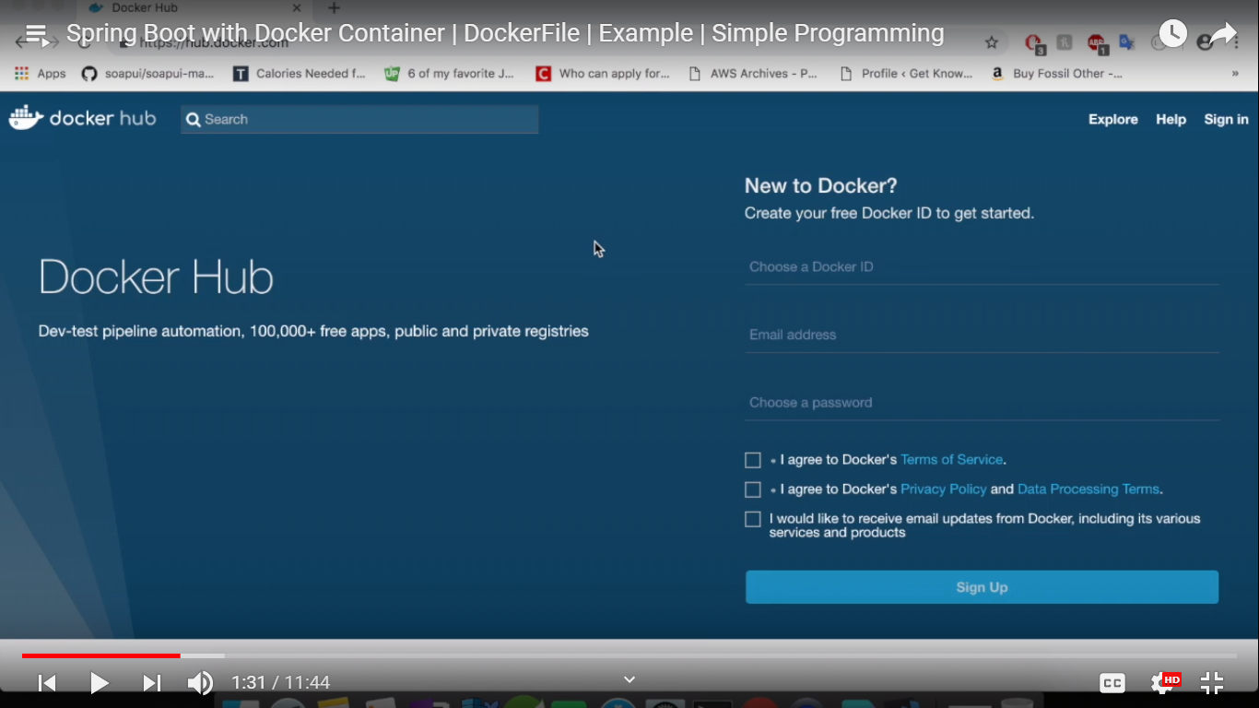

DockerFile

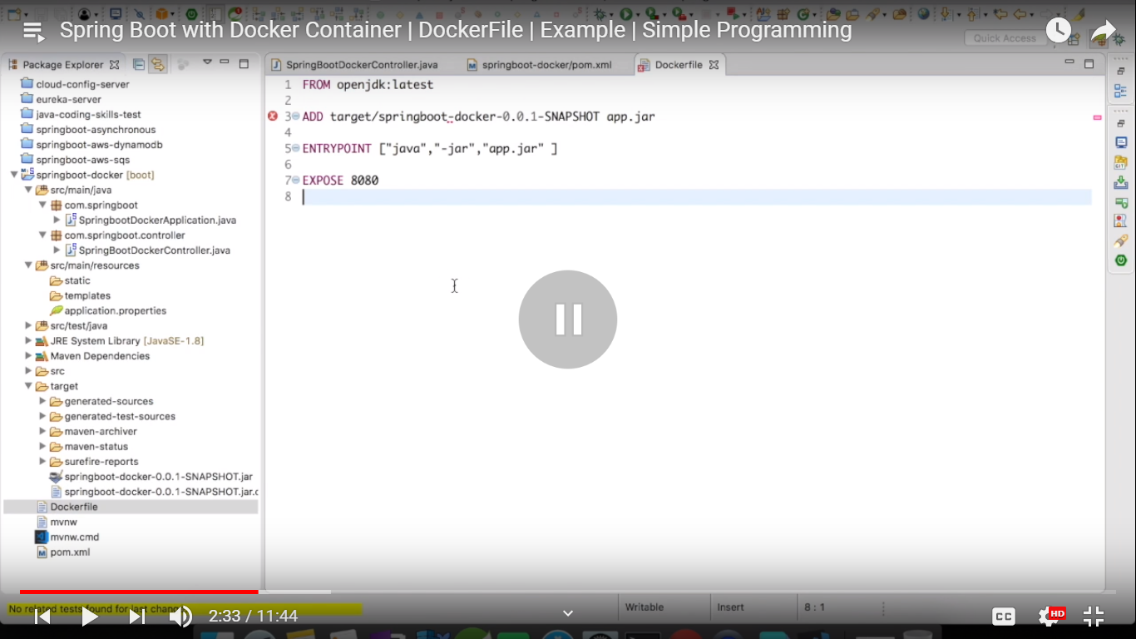

FROM openjdk:latest

ADD target/springboot-docker-0.0.1-SNAPSHOT.jar app.jar   
(renaming our spring boor jar as app.jar)

ENTRYPOINT [“java”,”-jar”,”app.jar”]

EXPOSE 8080

Openjdk is actual java, java is currently deprecated and openjdk is the java version that we use inside container.

Go to DockerHub homepage and search for java

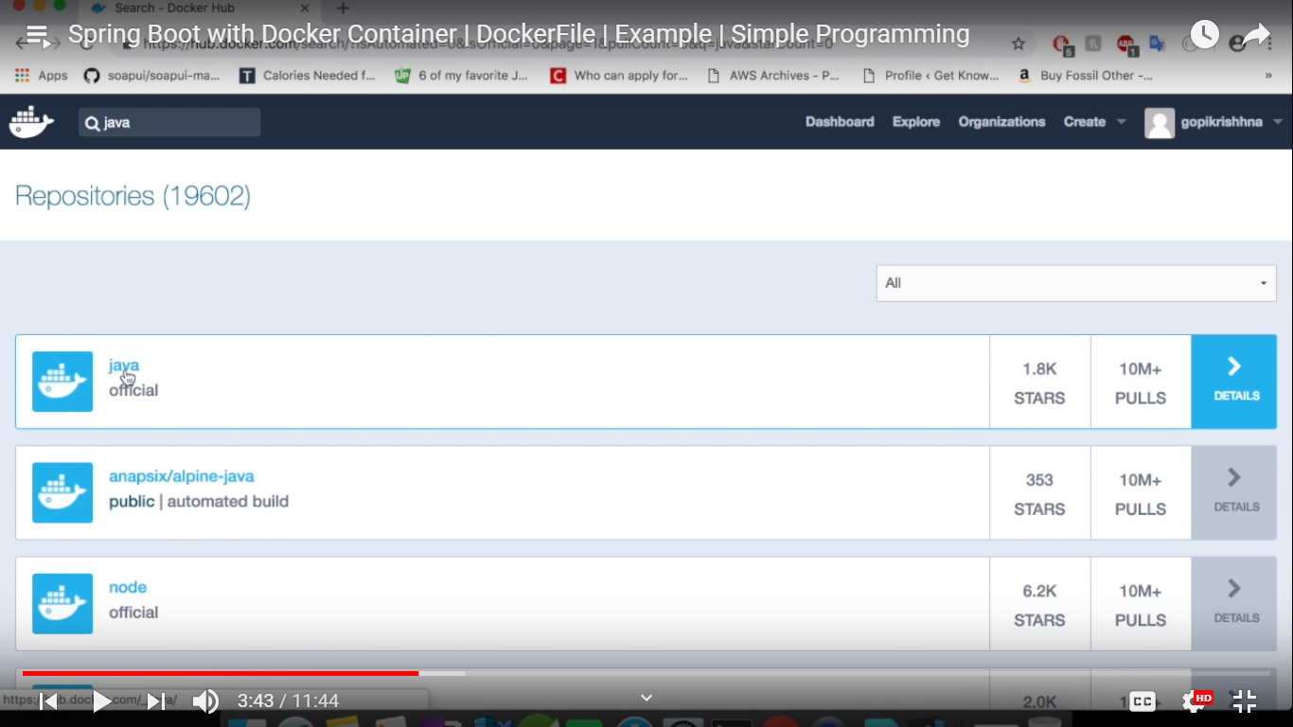

Click on java official and we can see that it has been deprecated

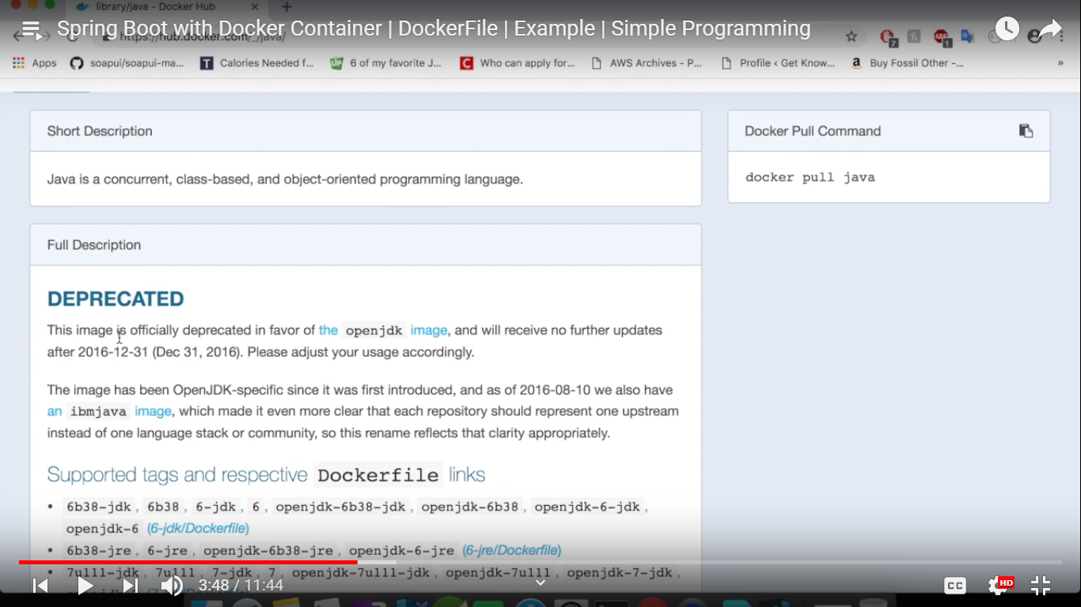

Click on openjdk from the above screenshot

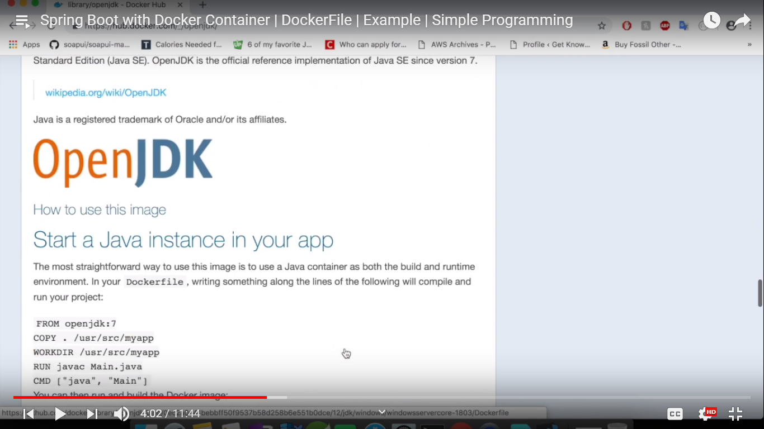

Suppose we want to use Cassandra

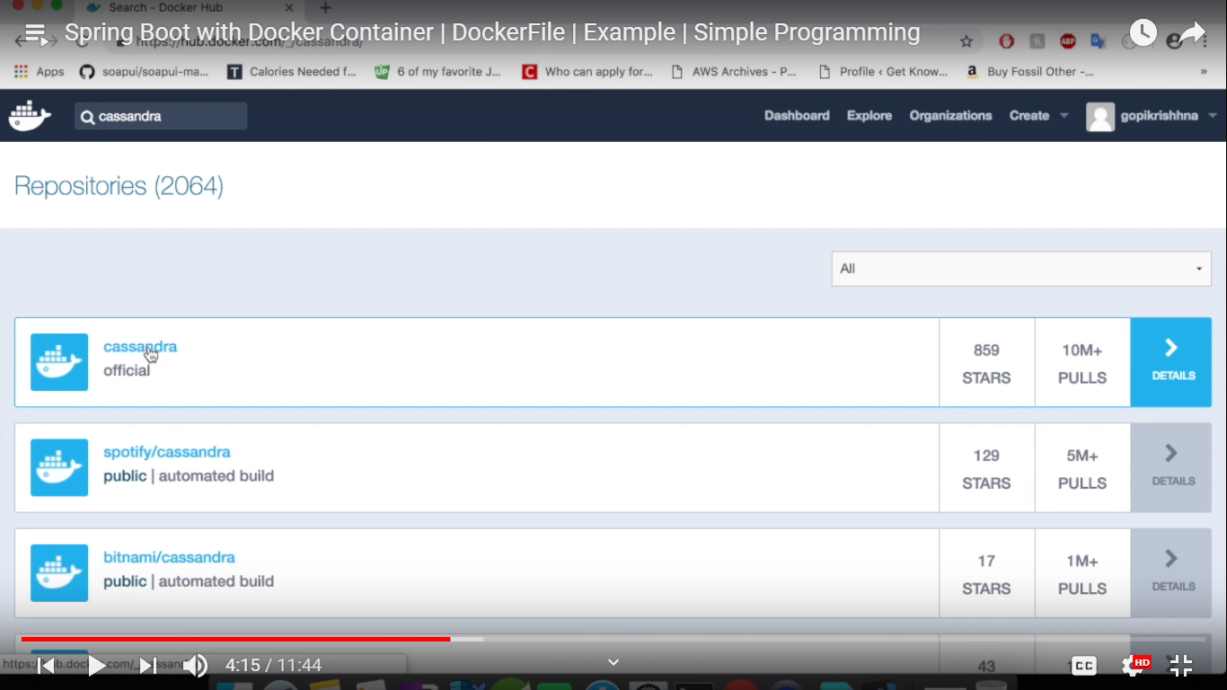

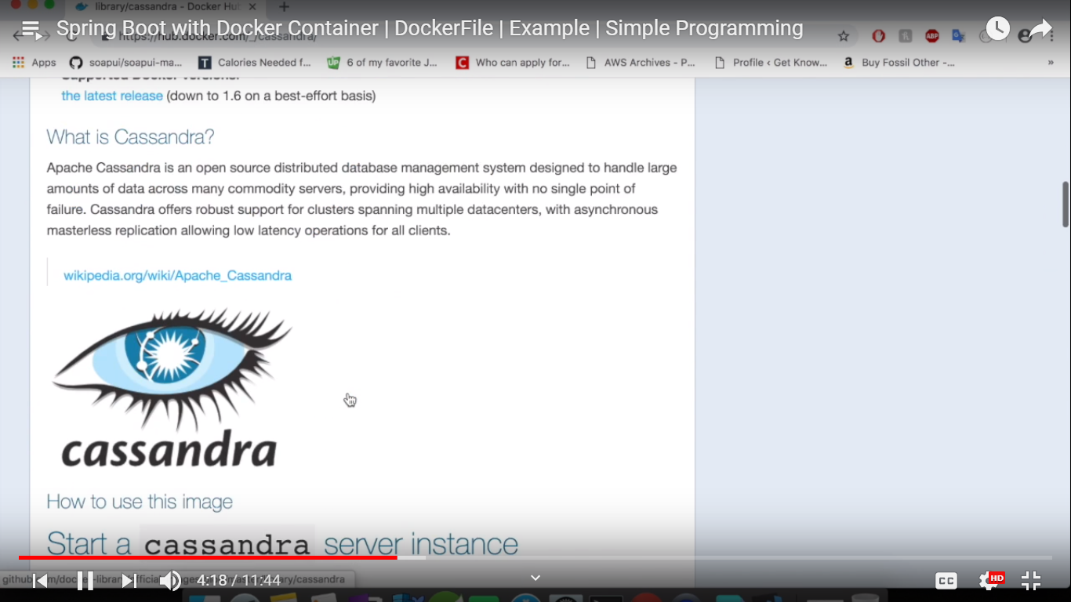

Docker commands

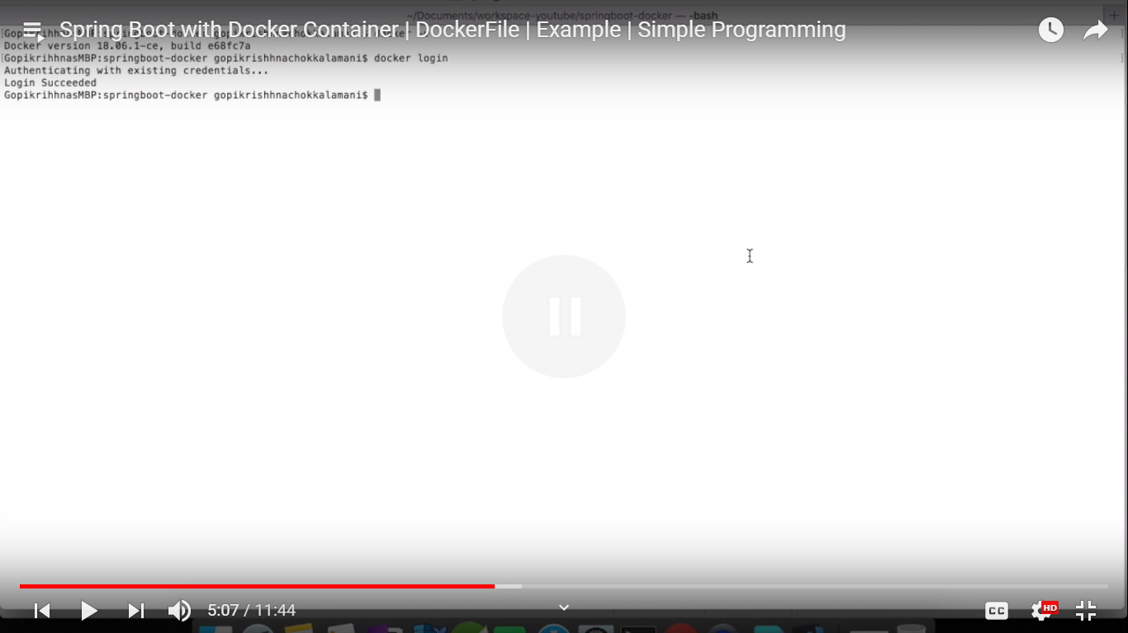

docker ps –a (it will give the list of container that are currently runnnig)

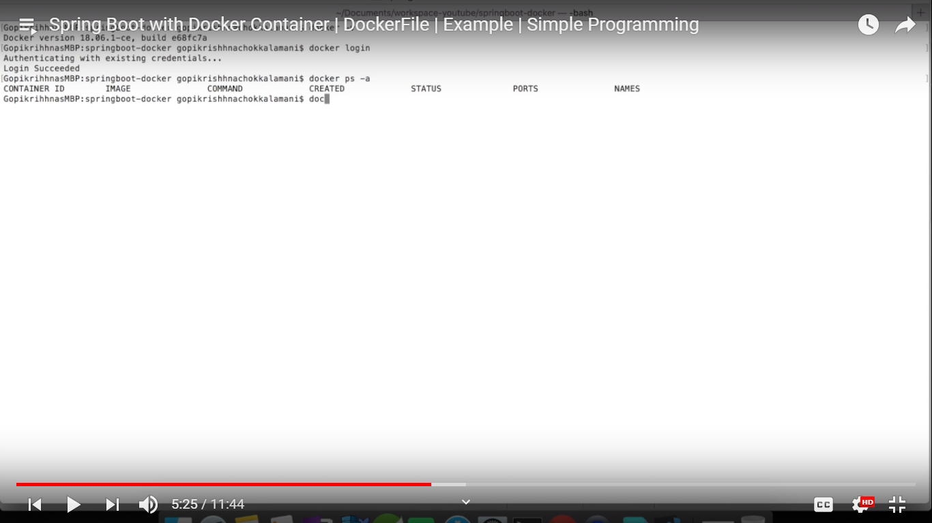

docker images (what are the images that we downloaded from the docker repository and what are images that you created in your local)

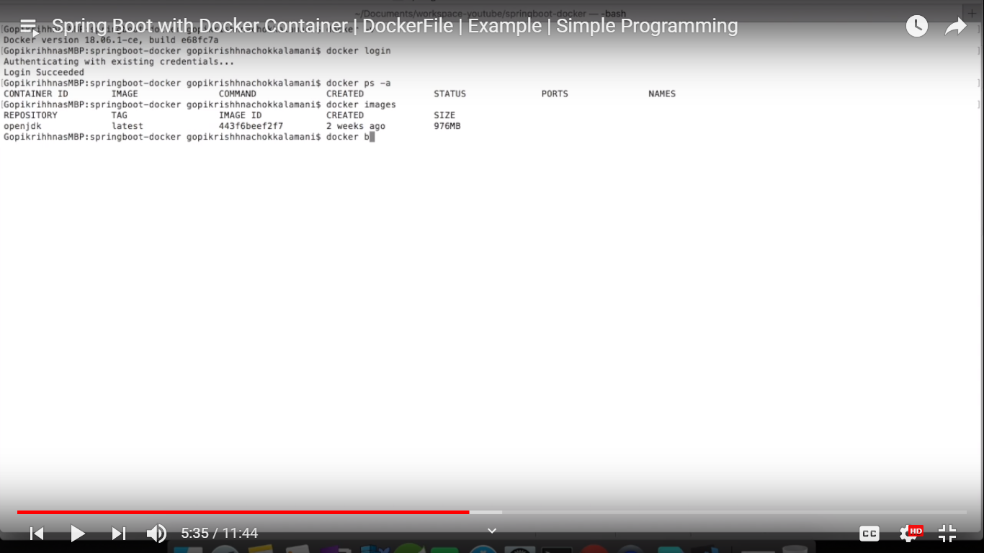

docker build target/ ()

All these commands are not needed if we are using docker file

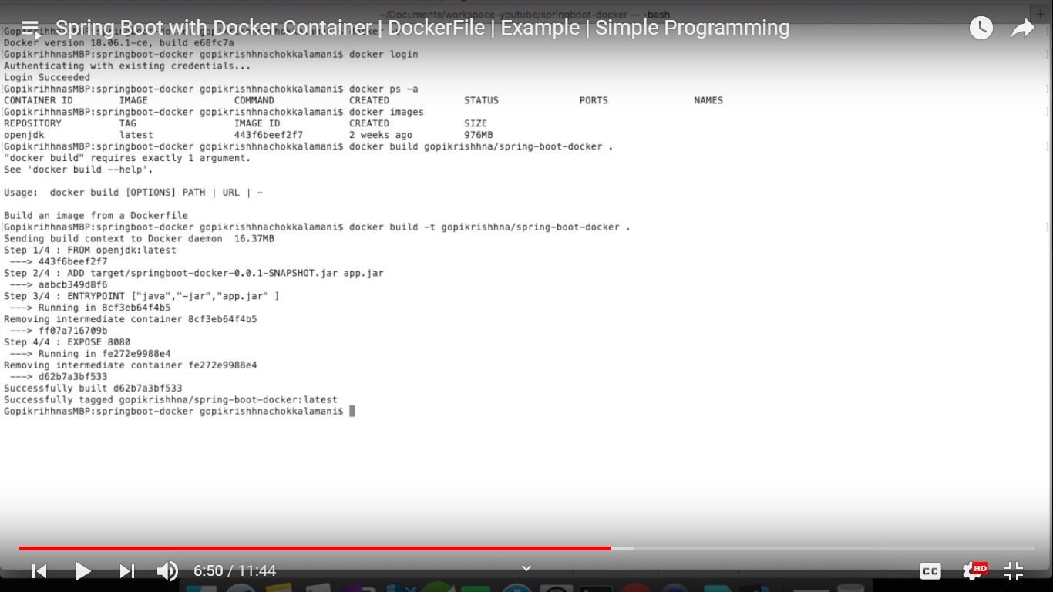

docker run –p 8000:8080 dockerImageName

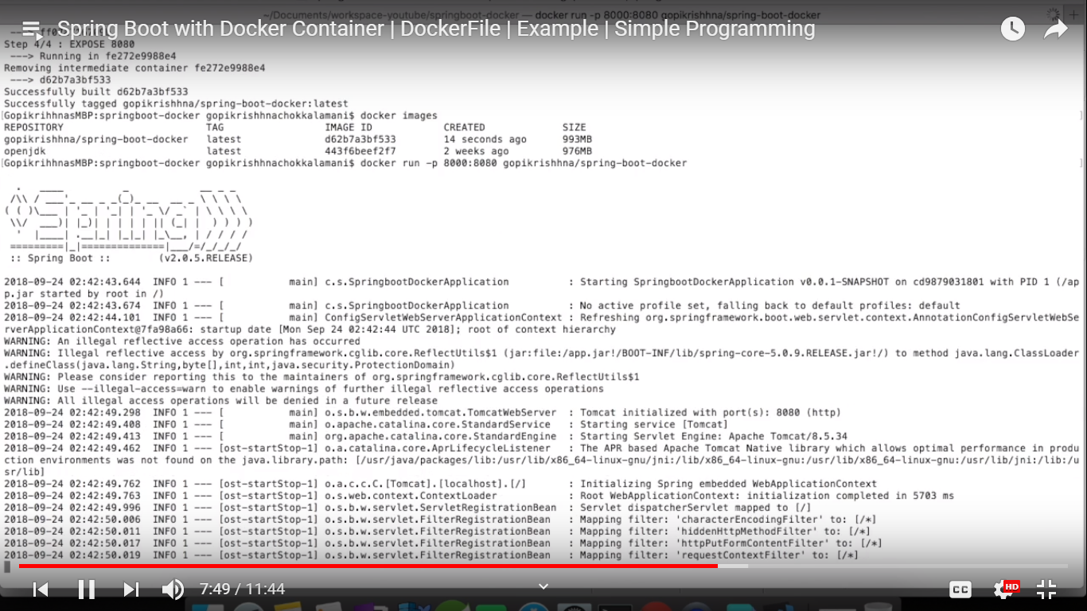

Now our application is up and running. Now let’s try to access this in the docker run port 8000

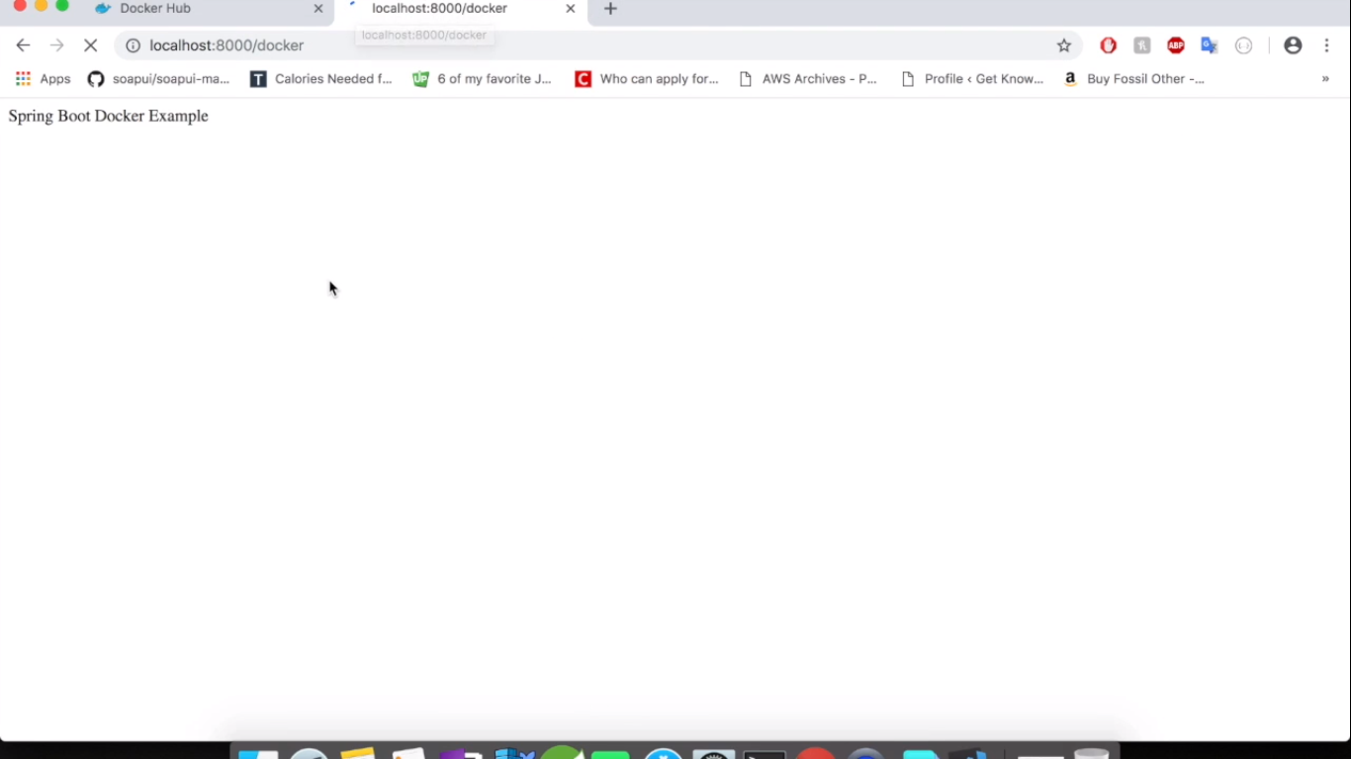

Now run the application as a background process

Previous docker image that we executed

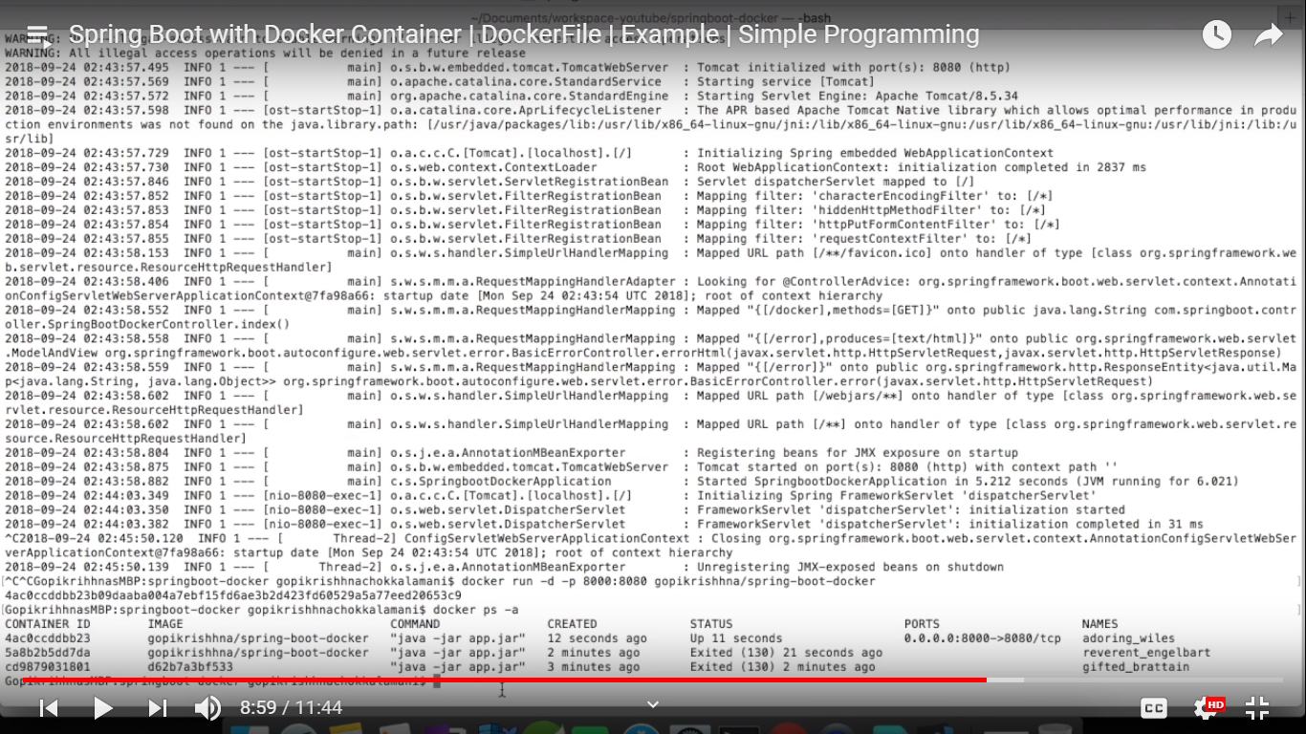

Now push to dockerhub

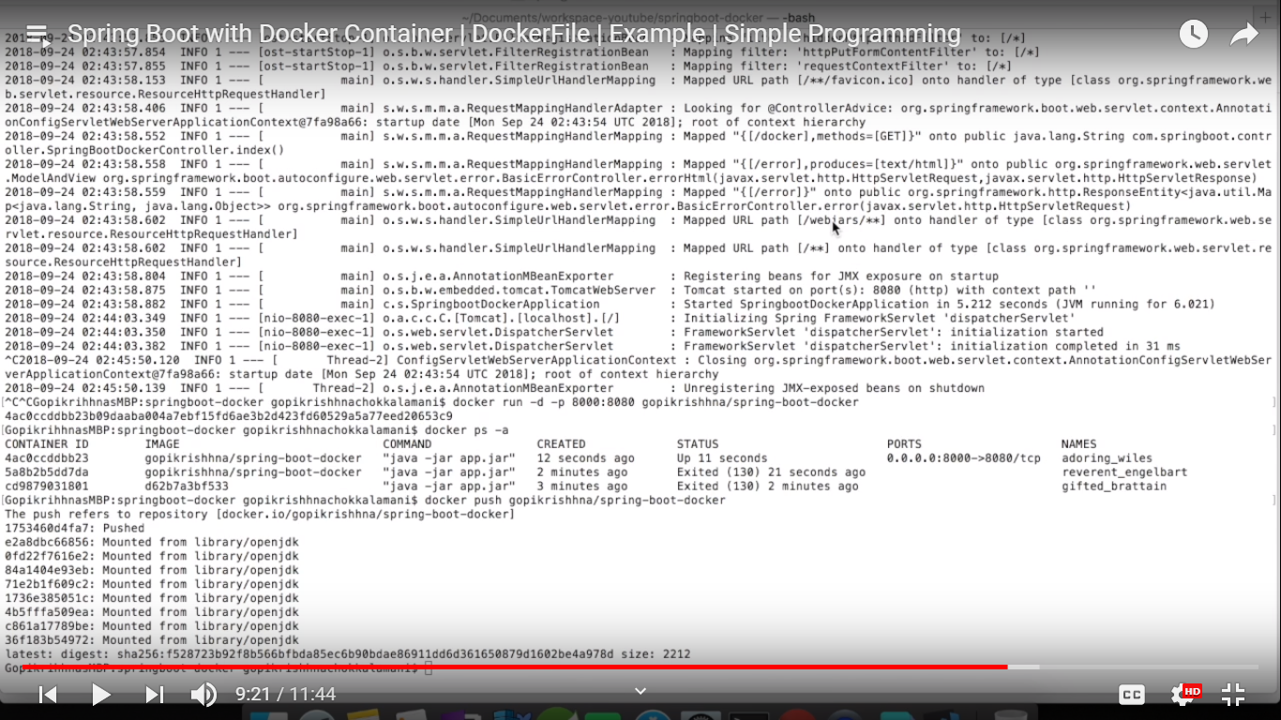

Push has been successfully done

Now check our dockerhub repository

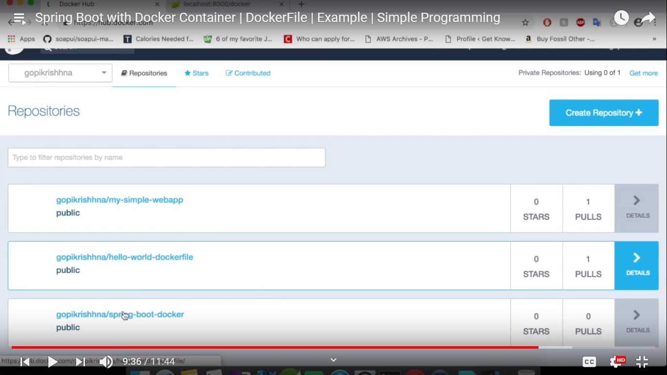

Go to console and delete all the container and images that we created

docker rm abc def ijk (give first 3 letters of the container id)

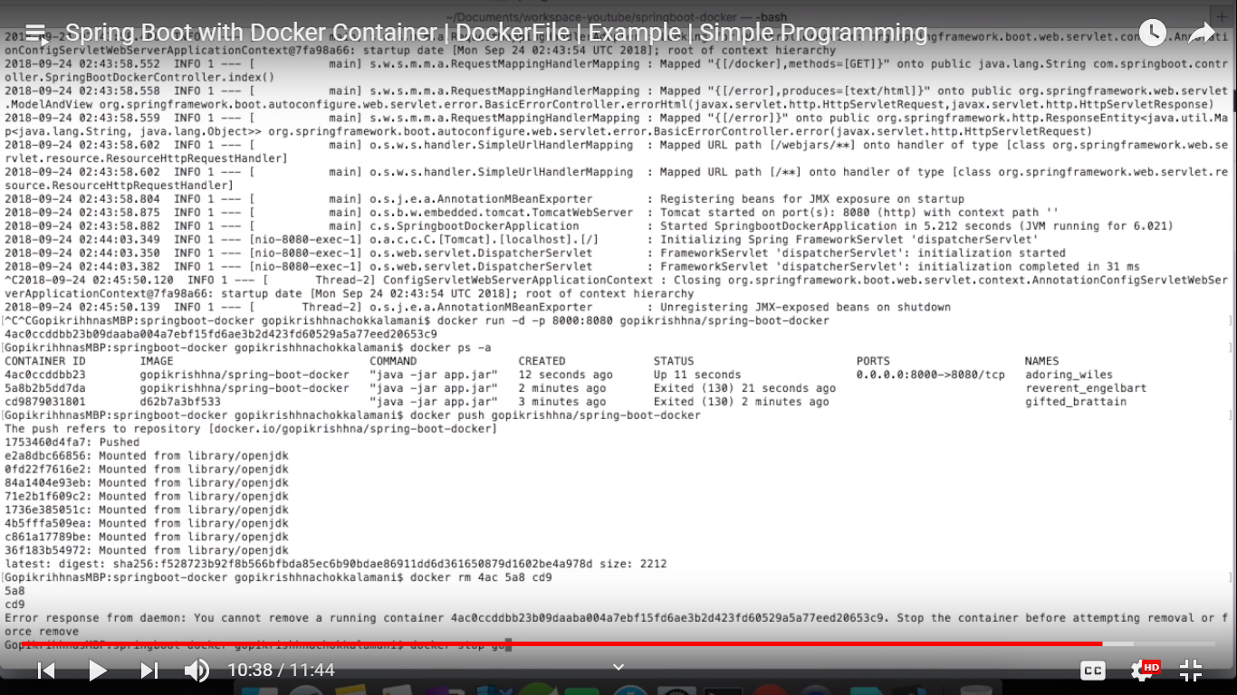

We need to stop the container to remove it

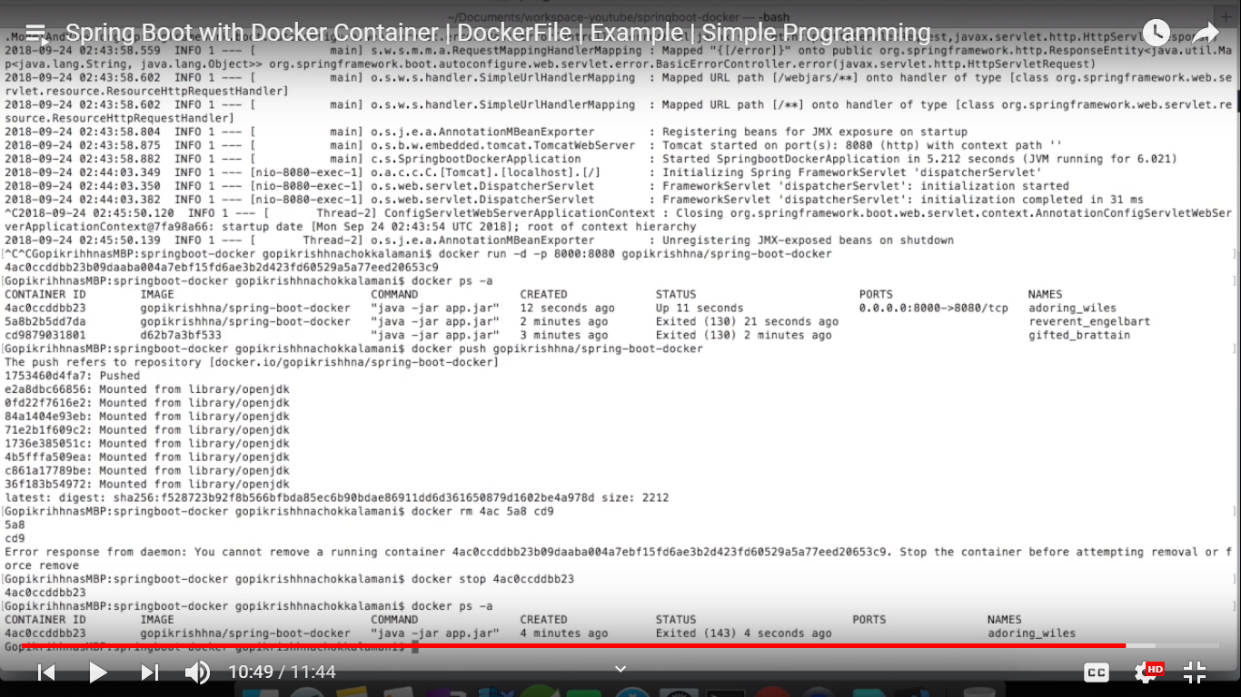

To remove a container we have to use **docker rm**

To remove an image we have to use **docker rmi**

No we remove the images

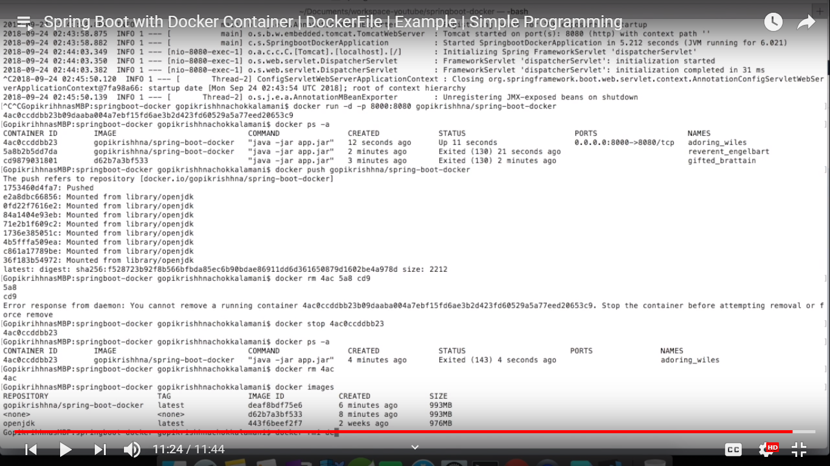

docker push

docker rm

docker rmi